*MATLAB Simulation of Forward*

*Planar Kinematics of a Two-Link Robot Arm*

*GEM 605 Activity*

Ivan John A. Naparota

University of San Carlos – Talamban Campus

Department of Electrical and Electronics Engineering

ivanjohnnaparota66@gmail.com

***Abstract* — this activity gives us a taste on the basic principle of Robotics referred to as Kinematics, it will only be considering a simple type of Robot Kinematics which is Forward Kinematics. In addition, for more simplicity of the activity, it will only be deliberating a robot mechanism having two degrees of freedom and it’s motion lying only to a two dimensional plane.**

***Keywords* – *Kinematics, Two-Dimensional Plane, Forward Kinematics, Robotics***

# I. INTRODUCTION

According to Merriam Webster Dictionary, kinematics is a branch of dynamics that deals with aspects of motion apart from considerations of mass and force, it is one of the fundamental principles used in Robotics by describing the behavior of the robot’s mechanism.

Kinematics in Robotics can be divided into Forward Kinematics and Inverse Kinematics, the former requires a little intricacy in deriving equations when solving related problems and the latter is much more expansive to compute. That is the reason why this activity, being given as the first assignment for the course MECE 617 will only be solving a problem of Forward Kinematics.

Calculating the position and orientation of the end-effector to a fixed coordinate system considering joints’ variable movements is called Forward Kinematics.

Referring to Drawing 1, the arm consists of two movable links that move within a two dimensional plane with X and Y being the axes. All links are connected with movable joints and the second link has an axis which is perpendicular to the first one.

# II. EQUATIONS AND MATLAB CODES

#### A. Equations

To describe the location of the end-effecter [xe , ye], a coordinate system *O* with *XY* as axes and origin at Joint 1 is made and the robot arm is hereby plotted to the plane.

As shown in Drawing 1, considering Link 0 to be fixed, Joint 1 to be driving Link 1, and Joint 2 to be driving Link 2, motion in Joint 1 will give an angle $θ_{1}$ and making Link 1 move, motion in Joint 2 gives an angle $θ_{2}$ also making Link 2 move.

Letting $l_{1}$ to be the length of Link 1, $l_{2}$ be the length of Link 2, behavior of the Two-Link Robot Arm is therefore represented in these equations,

$$x_{e}=l_{1}\cos{θ_{1}}+l_{2}\cos\left(θ_{1}+θ_{2}\right)$$

$$y_{e}=l_{1}\sin{θ_{1}}+l_{2}\sin\left(θ_{1}+θ_{2}\right)$$

#### B. MATLAB Codes

clc;

%getting the input from the user

prompt1 = 'Length of first Link: \n';

x = input(prompt1);

prompt2 = 'Length of second Link: \n';

y = input(prompt2);

prompt3 = 'First Angle in Degrees: \n';

z = input(prompt3);

prompt4 = 'Second Angle in Degrees: \n';

w = input(prompt4);

% x output, x coordinate of the end effector

outputX1 = x * cosd(z);

outputX2 = y * cosd(w + z);

outputX = outputX1 + outputX2;

% y output, y coordinate of the end effector

outputY1 = x * sind(z);

outputY2 = y * sind(w + z);

outputY = outputY1 + outputY2;

%displaying of the output

disp('X:');

disp(outputX);

disp('Y:');

disp(outputY);

%plotting in the xy coordinate system

axiss = x +y;

line ([0 outputX1],[0 outputY1] , 'color', 'r')

line ([outputX1 outputX],[outputY1 outputY])

title('2-Link Forward Kinematics')

xlabel('X-Axis')

ylabel('Y-Axis')

axis([-axiss axiss -axiss axiss])

grid on

%clear

clear all

disp('Type [Robotics1] in Command Window to Input again :)')

III. METHODOLOGY

Plot the Two-Link Robot Arm in an XY coordinate system with proper labels for a comprehensive diagram (refer to Drawing 1). Formulate mathematical equations that can describe the behavior of the robot arm’s motion.

Generate a code in MATLAB using the formulated equations and simulate.

IV. RESULTS AND DISCUSSIONS

As shown in Figure 2, the program will ask inputs, Length of Link 1, Length of Link 2, First Angle in Degrees, and Second Angle in Degrees respectively, furthermore, given the following criteria:

Length of Link 1: 4 units

Length of Link 2: 3 units

First Angle in Degrees: 30o

Second Angle in Degrees: -70o

We’ll get an outcome of point (5.7622, 0.0716) which will be the location of the end-effector with respect to the XY coordinate system.

V. CONCLUSIONS

The position and orientation of the end-effector of a Two-Link Robot Arm in a two dimensional plane can be computed with forward kinematics, also, MATLAB is of great help in computing end-effector’s position without the need for manual mathematical solutions.

VI. DRAWINGS AND FIGURES

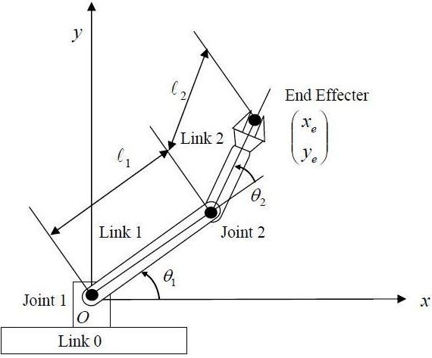

Drawing 1.Planar Two-Link Robot Arm

##### 

Figure 1.Plot of Two-Link Robot Arm in MATLAB

##### 

Figure 2.MATLAB Command Window